**BUS RESERVATION SYSTEM**

Project Report

Subject: IT-203 Object Oriented Programming & Lab (PRS)

BACHELOR OF TECHNOLOGY IN

INFORMATION TECHNOLOGY

3rd Semester

Submitted by: VARUN KUMAR (2K19/IT/140)

YASHIT KUMAR (2K19/IT/149)

Under the Supervision of

Mrs. Geetanjali Bhola

Assistant Professor



DEPARTMENT OF INFORMATION TECHNOLOGY DELHI TECHNOLOGICAL UNIVERSITY (Formerly Delhi College of Engineering) Bawana Road, Delhi-110042

**DELHI TECHNOLOGICAL UNIVERSITY**

(Formerly Delhi College of Engineering)

Bawana Road, Delhi-110042

**CANDIDATE’S DECLARATION**

We Varun Kumar, Roll No – 2K19/IT/140 & Yashit Kumar, Roll No - 2K19/IT/149, students of B.Tech. (INFORMATION TECHNOLOGY), hereby declare that the project Dissertation titled “Bus Reservation System” which is submitted by us to the Department of INFORMATION TECHNOLOGY, Delhi Technological University, Delhi in partial fulfillment of the requirement for the award of the 3rd semester of the Bachelor of Technology, is made by us. This work has not previously formed the basis for the award of any Degree, Diploma Associateship, Fellowship or other similar title or recognition.

Place: Delhi

Date: 18-11-2020

Varun Kumar

Yashit Kumar

DELHI TECHNOLOGICAL UNIVERSITY

(Formerly Delhi College of Engineering)

Bawana Road, Delhi-110042

**CERTIFICATE**

I hereby certify that the Project: "**Bus Reservation System**" which is submitted by Varun Kumar, Roll No – 2K19/IT/140 & Yashit Kumar, Roll No – 2K19/IT/149, INFORMATION TECHNOLOGY, Delhi Technological University, Delhi in fulfillment of the requirement for the 3rd semester of Bachelor of Technology, is record of the project work carried out by the students under my supervision. To the best of my knowledge this work has not been submitted in part or full for any Degree or Diploma to this University or elsewhere.

Place: Delhi **Supervisor** : Mrs.Geetanjali Bhola

Date: 18-November-2020 (Assistant Professor)

**DEPARTMENT OF INFORMATION TECHNOLOGY**

**DELHI TECHNOLOGICAL UNIVERSITY**

(Formerly Delhi College of Engineering)

Bawana Road, Delhi-110042

**ACKNOWLEDGEMENT**

We would like to convey our heartfelt thanks to our supervisor Mrs. Geetanjali Bhola for her ingenious ideas, tremendous help and cooperation.

We are extremely grateful to our friends who gave valuable suggestions and guidance for completion of our project. The cooperation and healthy criticism came handy and useful with them.

Finally we would like to thank all the above mentioned people once again.

**TABLE OF CONTENTS**

|  |  |
| --- | --- |
| **1 . INTRODUCTION** | **6 - 8** |
| **2. FEATURES** | **9 - 11** |
| **3. OOP CONCEPT USED** | **12 - 14** |
| **4. WORKING DEMO** | **15 - 23** |
| **5. SOURCE CODE LINK** | **24** |
| **6. BIBLIOGRAPHY** | **25** |

**INTRODUCTION**

Traveling is a large growing business across all countries. It includes maintenance of information like schedule and details of each bus.

We observed the working of the Bus reservation system and after going through it, we get to know that there are many operations, which they have to do manually. It takes a lot of time and causing many errors while data entry. Due to this, sometimes a lot of problems occur and they were facing many disputes with customers.

So we decided to make C++ console based application on Bus Reservation System

The Aim of Our Project is to understand and implement the concepts of object-oriented programming we learnt throughout our semester with C++ and make a program out of it .

The project: “Bus Reservation System” uses most of the features of OOP, and made using C++.

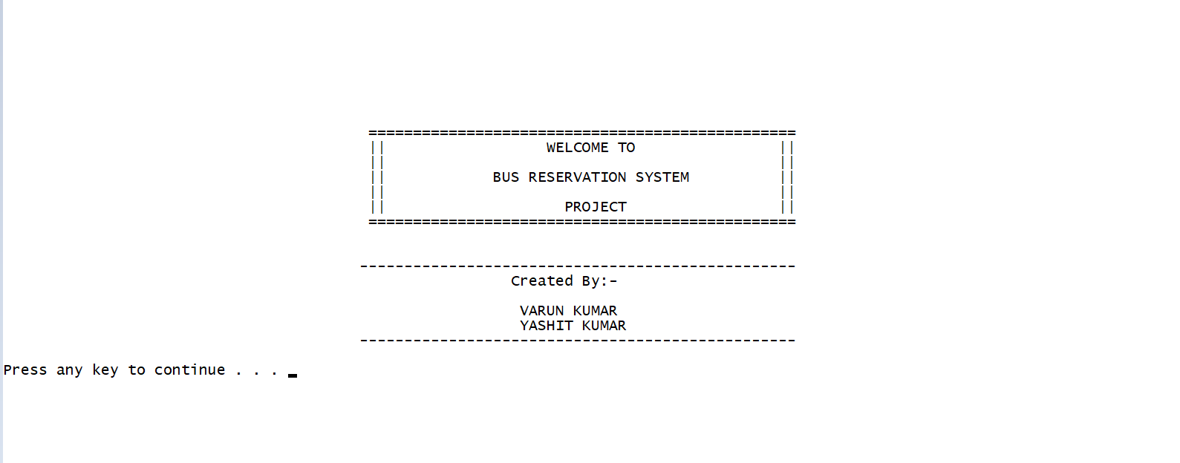

**FEATURES OF OUR PROJECT**

We have divided system into two portals : -

1. Passenger 2 .Bus Authority

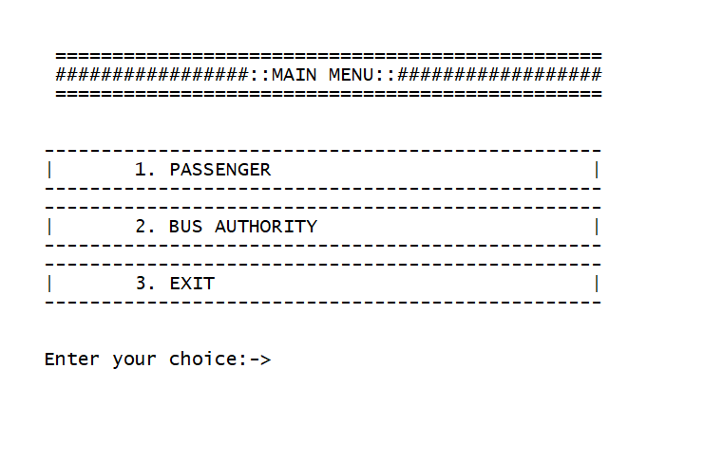

**What Passenger can do ?**

**1 . Book a Bus Ticket**

**2. Can view his/her bookings**

**3. Can cancel Ticket**

**4. Can Modify Ticket**

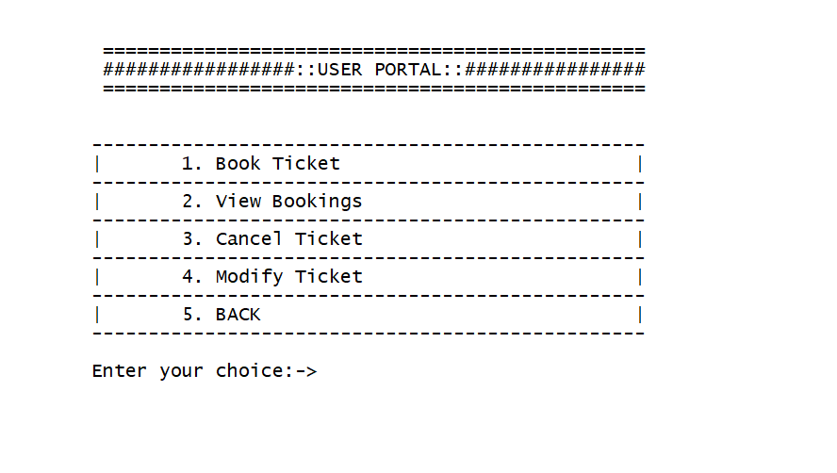

**Bus Authority**

**1. Add Bus**

**2. View All Buses**

**3. View All Bookings**

**4. Show Bus Booking**

**5. Modify User Booking**

**6. Delete Bus**

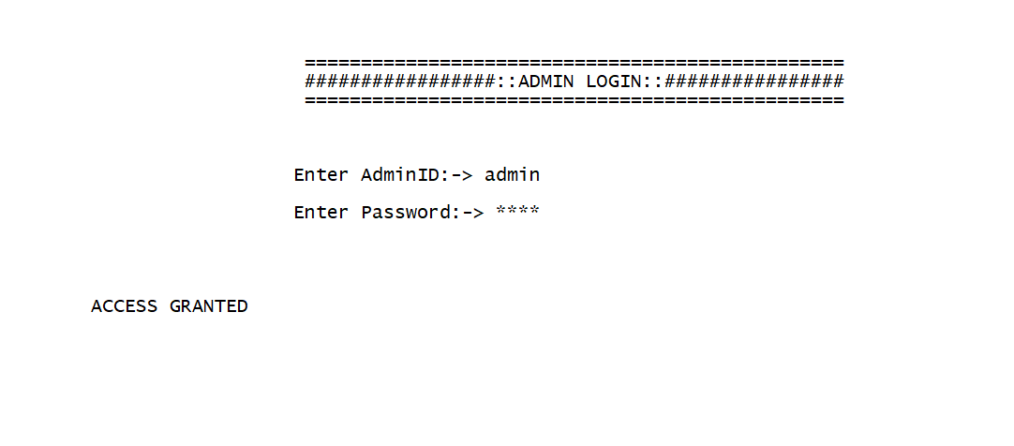

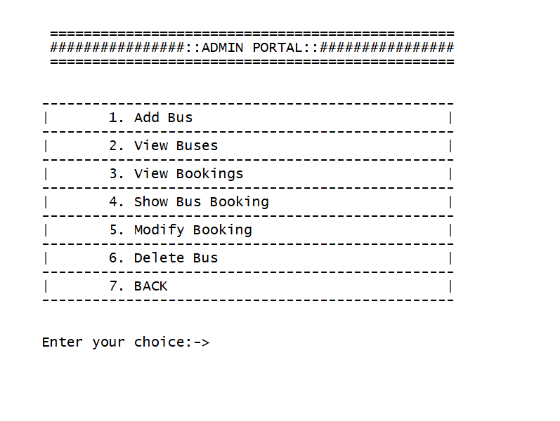

**OOP CONCEPT USED**

**Abstraction -** It is one of the most essential and important feature of object oriented programming in C++. Abstraction means displaying only essential information and hiding the details.

**Classes Created :-**

**1. Bus**

**2. Customer**

**3. Admin**

**4. Ticket**

**Encapuslation -** Encapsulation is defined as binding together the data and the functions that manipulates them.

All the four classes have this feature

**Friend Function / Classes Used –** A friend class can access private and protected members of other class in which it is declared as friend.

So we make class admin and ticket friend of class Bus so that admin can access Bus data

A friend function can be given special grant to access private and protected members

Functionality cancel ticket and modify ticket can be used by both admin class and customer so we make both the functions friend .

**Exception Handling -** A C++ exception is a response to an exceptional circumstance that arises while a program is running, such as an attempt to divide by zero

It is used when admin try to enter the information about bus and enter invalid info and also it is used when the user is trying to enter wrong password at admin portal.

and also when Customer tries to enter invalid info

**File Handling -** File Handling is used to store the record of the user tickets and buses .

**WORKING DEMO**

**Admin Installing Buses**

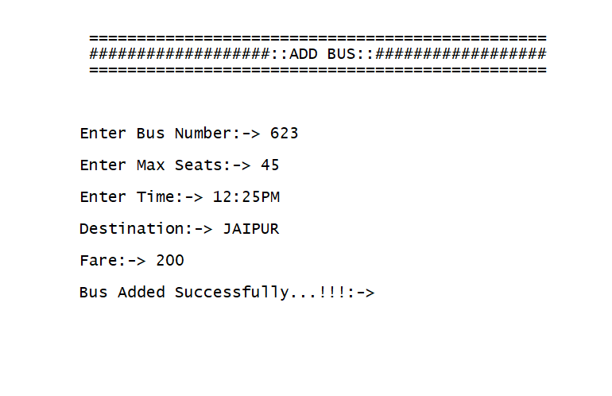

**View all Buses via admin**

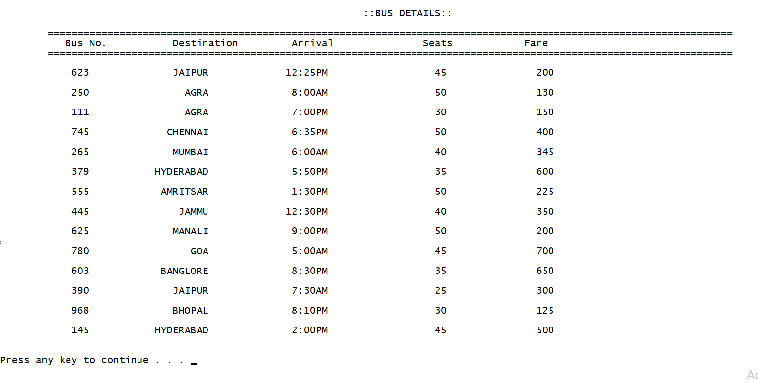

**Admin can delete Bus**

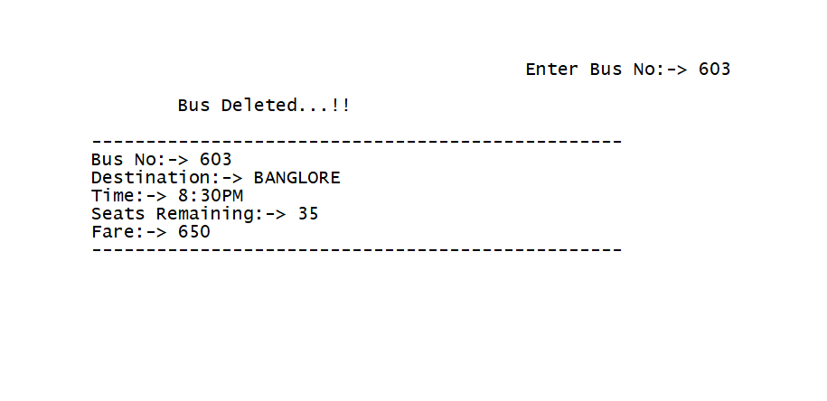

**Passenger can Book Tickets**

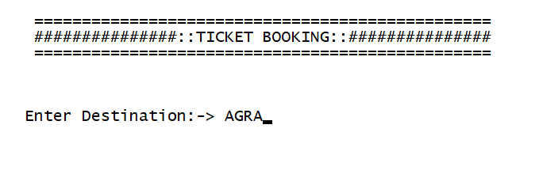

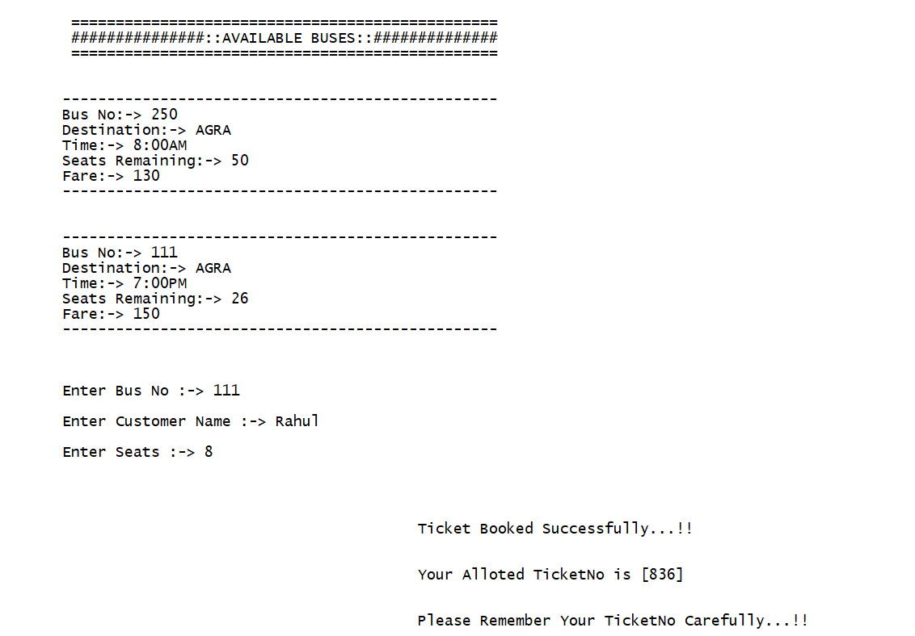

**Passenger can view his Reserved Ticket**

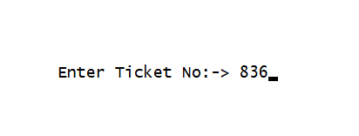

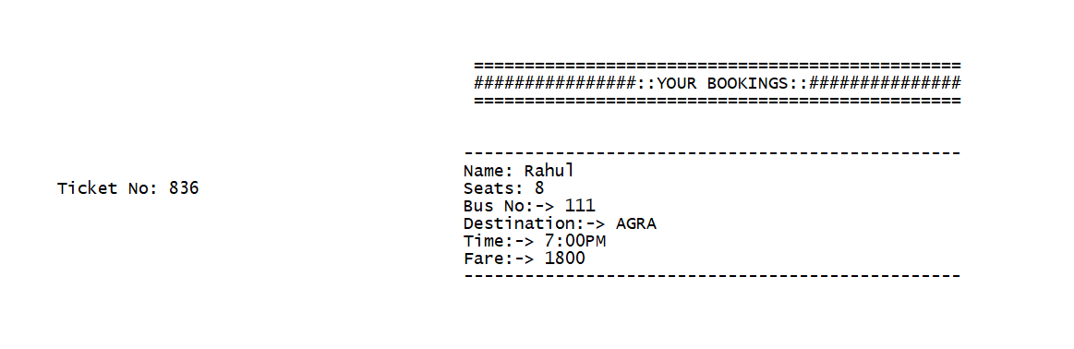

**Passenger or Admin can modify his name and seats on ticket**

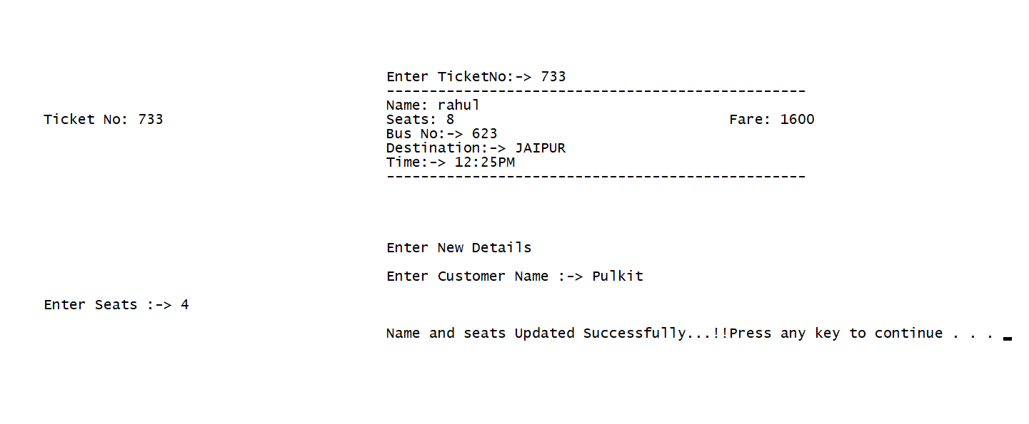

**Admin can View all Bookings**

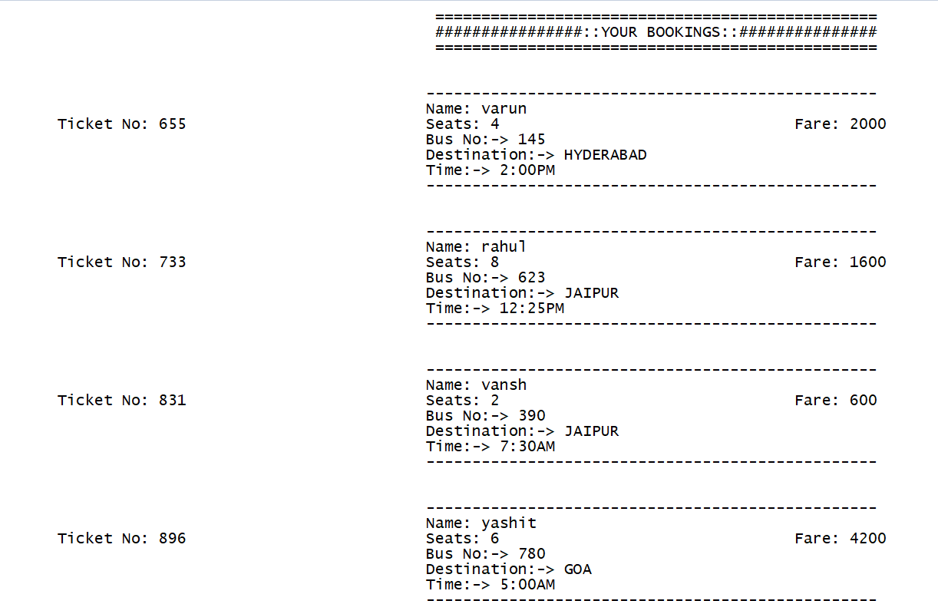

**Passenger or Admin can cancel Ticket**

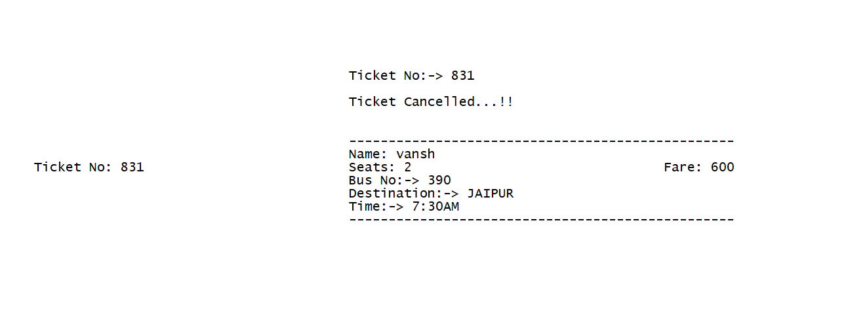

**Admin can view a particular Bus Tickets**

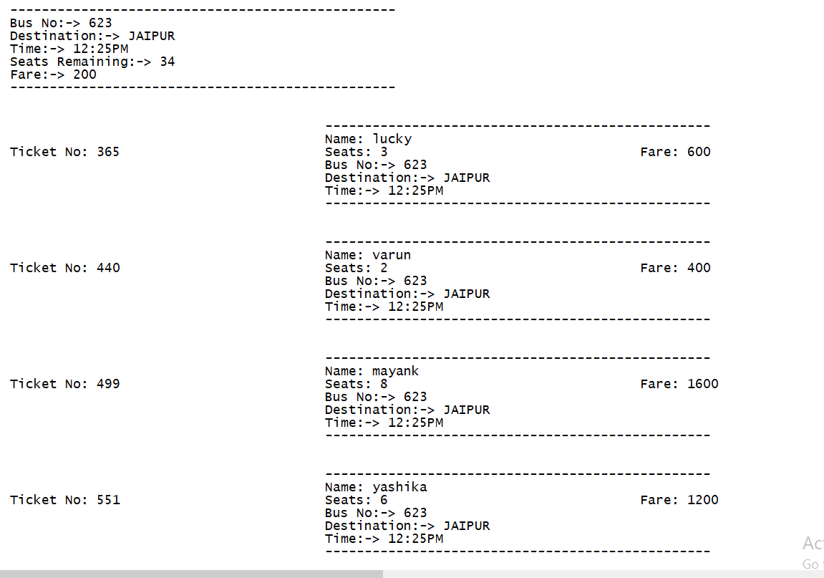

**SOURCE CODE GITHUB LINK**

**https://github.com/varunkmr038/OOP-Project/blob/main/Bus%20Reservation%20System.cpp**

**BIBLIOGRAPHY**

<https://www.geeksforgeeks.org/object-oriented-programming-in-cpp/>

Geetanjali Mam Notes

<https://www.geeksforgeeks.org/friend-class-function-cpp/>

[https://www.geeksforgeeks.org/file-handling-c-classes](https://www.geeksforgeeks.org/file-handling-c-classes/)